1. So, obviously, we can have a totally chaotic approach as I shown you in the last lecture with totally different documents in same collection or we follow a SQL world like approach where we make sure that all elements, all entries (documents) have exactly the same schema and there is no extra entry on any document.
2. **Different Kinds of Approach:** 
   1. **Chaotic World**: Where we have got different kinds of documents with totally different schemas which is not needed in real world.
   2. **In B/w:** Where you have got some kind of schema according to which you can add some extra info to some documents but the general schema is the same (There are some core fields which exist on each document).
   3. **Strict:** Where each document has got the same structure.
3. 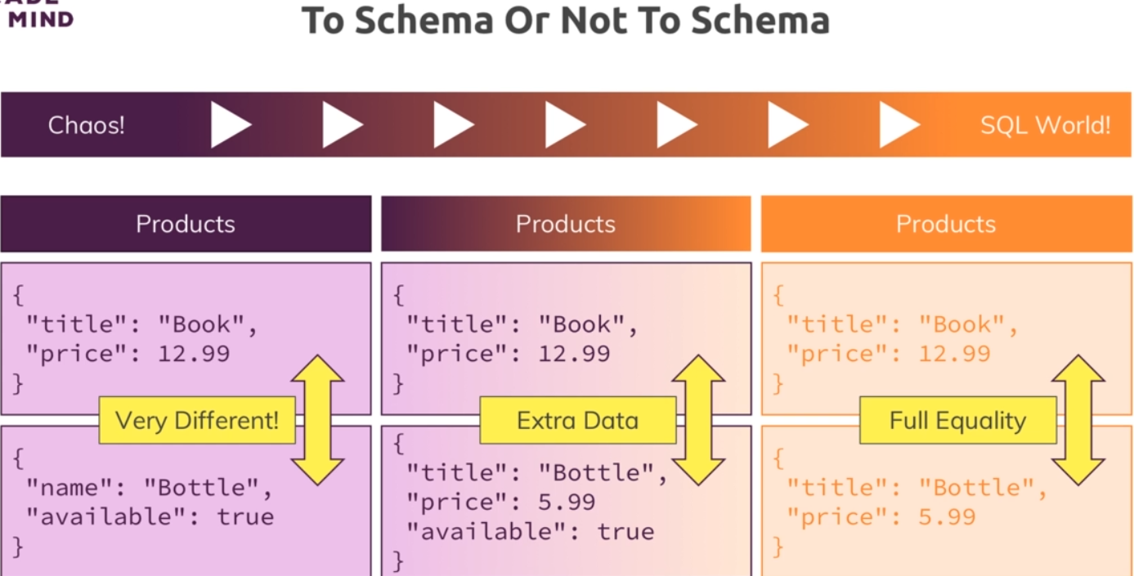
4. **Command**🡺To delete all the entries from the collection:
5. 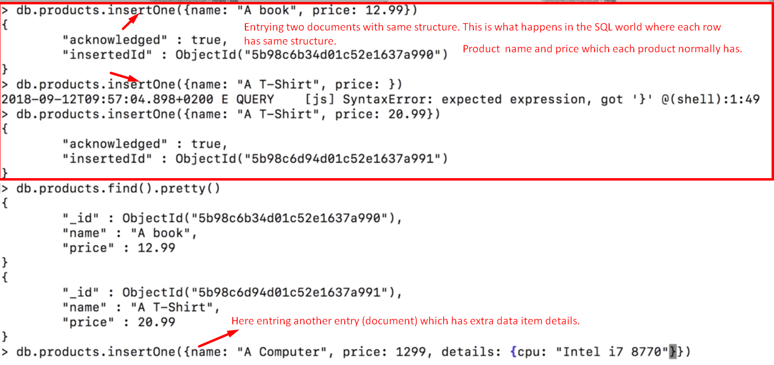
6. 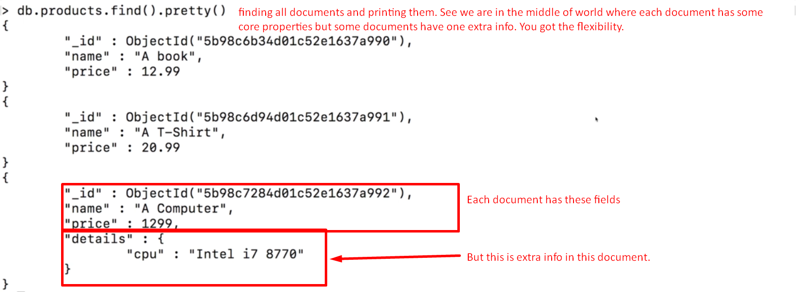
7. 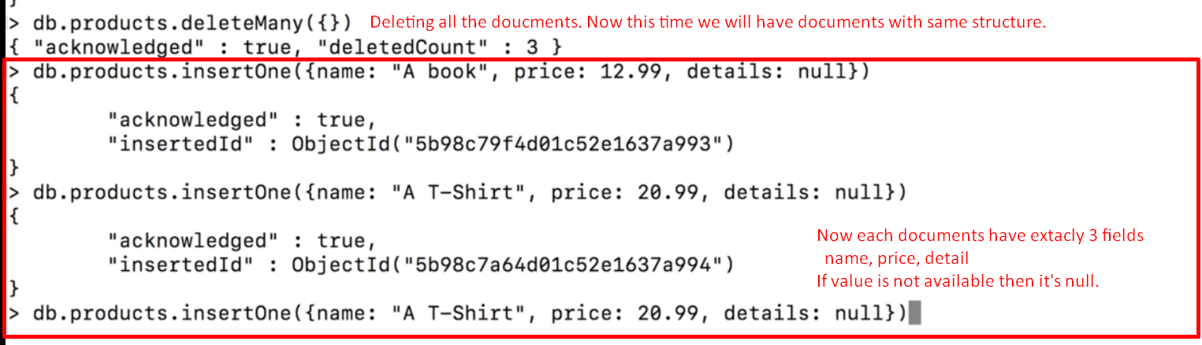
8. Whichever approach is better for you, you can go for that.